MIXED SIGNALS -

A MODERN CALL OF CTHULHU 7E SCENARIO

BY TOM E. SHKURTI -

This work is licensed under a Creative Commons Attribution-ShareAlike 4.0 International License.

INTRODUCTION
Mixed Signals is a self-contained, modern era Call of Cthulhu 7th Edition scenario dealing with alien radio transmissions, broadcast signal intrusions, and the monstrous consequences thereof.
It is intended for investigator groups of any size with moderate to heavy Mythos experience. Due to its subject matter, it is advisable that at least one investigator possesses significant skills in Electronics, Electrical Repair, Science (Physics), Science (Astronomy), or similar technical fields. Combat is balanced for investigators with substantial arsenals, although clever non-combat groups may be able to avoid violence altogether.
The scenario is nominally set in Los Angeles in the year 2024, although nothing binds it to that particular time or place. Any town large enough to have its own television news channel is capable of serving as the focal point, although the strange incidents that occur are most likely to escape wide notice in a major city. Due to its heavy reliance on television and video recording technology, it is probably not workable before the commercial advent of VHS tape in the 1970s. The “WOW! Signal” emanating from near the star χ¹ Sagitarii, which plays a minor role in the scenario’s background, was received in 1977.

KEEPER’S BACKGROUND
The events of Mixed Signals were first set in motion 252 years ago, and exactly that many light-years from Earth, when a dense cosmic object passed near the binary star system χ¹ Sagitarii. Its gravitational field affected the orbit of every planet in the system: in a complex process spanning hundreds or thousands of years, they would settle into new orbits, eject from the system entirely, or be torn apart by tidal forces. The inhabitants of χ¹ Sagitarii V, possessed of great scientific and magical ability, understood their world would soon become uninhabitable even before any of that came about- even the early stages of the shift, climate changes and tidal shocks would cause unimaginable devastation. The last act of the “Sagittarians” would be to send out a complex radio signal- perhaps a plea for help, perhaps a desperate attempt to “beam” themselves en masse to another location, or perhaps just the directionless screams of a dying civilization. Whatever it was, the ghosts of χ¹ Sagitarii V are bound up within it.
Enter Enrique Diaz, broadcast equipment technician at the Los Angeles TV news outlet KWLA. A dabbler in the intersection between science and the occult, he stumbled across the Sagittarian signal intruding on KWLA’s broadcasts and was instantly entranced. He began staying at the studio after hours, fiddling with the equipment to receive, amplify, and analyze the mysterious transmission. His constant distraction eventually got him fired, and from then on he had to content himself with buying or stealing components to continue the work in his dingy, one-room apartment. Eventually, Diaz’s strange new hobby got the better of him. Convinced he could physically “get to the other side” in a fit of temporary insanity one night, he slammed his head into an old CRT television set and sliced his carotid artery open on a shard of glass.
Unknown to Diaz (and anyone else), he wasn’t just picking up video: ghostly “Echoes” of the Sagittarians also materialize whenever the Signal is intercepted by terrestrial equipment. Usually they are harmless, and all but invisible to humans. Sometimes they are not. As the Signal is unwittingly intercepted by KWLA’s viewing audience, more Echoes are spawned throughout the city. Their encounters with humanity (and the deleterious mental effects of the Signal itself) are starting to have bloody results.

STRUCTURE
The first half of Mixed Signals is freeform. Multiple ‘hooks’ are presented as ways to introduce the Signal threat, and fatal encounters with the Echoes or Signal can occur at any point to provide clues and a sense of urgency [4]. The objective is to get the investigators to analyze the Signal’s properties and origin [8]. This will lead them to KWLA’s studio [13] and the scenario’s more structured second half: a confrontation with an Echo in the KWLA basement [15], Enrique Diaz’s apartment [24], and a final ritual to purge the Echoes using the studio’s antenna [30].

HOOKING THE INVESTIGATORS
If the Keeper feels the investigators are sufficiently inquisitive, it might be sufficient to simply have a broadcast signal intrusion occur while one or more of them are watching television. This on its own may be enough to get them to either ask around if others have been having the same problem, or sit in front of the TV for long enough to see the event repeat. A less subtle way of introducing the scenario through the Signal itself would be to have other people -friends of an investigator, random people on a paranormal message board, or what-have-you- already be discussing the intrusions and whether there is anything unusual about them. See THE BROADCAST SIGNAL INTRUSIONS [3] for more information on what the intrusions involve.
Alternatively, the Keeper may wish to start off the scenario with an incident where the Signal or the Echoes got somebody hurt or killed. Several such incidents are described in the “IF IT BLEEDS, IT LEADS” section [4]. Hopefully after one or two (or, God forbid, several) such incidents, the investigators should recognize the television signals as a common element. This could be a particularly enticing option for investigators affiliated with medical services, law enforcement, or the media.
A third option would be to have the investigators be employees of KWLA. In this case, they would know about the signal intrusions from the start, either from general workplace scuttlebutt or because they were told to look into the problem by management. This will then likely carry on similarly to the first introduction option. On the other hand, it might be interestingly creepy to have investigators working as KWLA reporters sent out to cover seemingly ordinary murders and traffic accidents, and realize their own station is receiving at an increasing number of the scenes!

THE BROADCAST SIGNAL INTRUSIONS
KWLA is a local Los Angeles television news station, which has the unfortunate honor of broadcasting on a radio frequency close to that used by the Sagittarian Signal. Occasionally, when conditions are right, the Signal creeps into KWLA’s broadcasts.
The Signal only strikes Earth roughly between the hours of midnight and 4:00 AM, although never at quite the same time each night. Throughout this entire period, the quality of the usual broadcast is degraded. “Sensitive” individuals (psychics, children, people with high Cthulhu Mythos or low SAN, or whatever other categories the Keeper wishes) can sense that there is something profoundly disorienting about the content, but nothing concrete can be discerned.
Every 5d4 minutes during its active period, the Signal comes through much more strongly. These events begin with a 6-second period of increasing audiovisual degradation in the program. Then, the program is replaced entirely by a high-frequency, discordant digital noise, and a rapidly strobing series of concentric luminous rings half-buried in static and racing “towards” the screen. This lasts about 10 seconds, after which the original broadcast resumes.
Anyone viewing even a few seconds of the fully-manifest Signal is stricken with a sudden, overpowering claustrophobia, which deals 1d3/2d4 Sanity damage. Additionally, anyone failing the Sanity roll is compelled to flee to a larger space, preferably open to the sky. The compulsion lasts for a number of rounds equal to the Sanity lost, times two. People afflicted act without regard for personal safety and may jump out windows, flee into oncoming traffic, or otherwise endanger themselves. These reactions are what killed most of the victims in the “IF IT BLEEDS, IT LEADS” incidents [4] (the Echoes got the others). A generous Keeper may allow a second Sanity roll to end the fit early, if an investigator is at the risk of doing something definitively lethal.
Each and every manifestation of the Signal also spawns an Echo somewhere nearby. It is up to the Keeper to decide whether that Echo sticks around, or shuffles off unnoticed to wreak havoc elsewhere later on. It is recommended that the Echo not appear if the investigator is encountering the Signal for the first time unexpectedly or “in the wild”- better to not distract from the strangeness of the event itself by piling on too many dimensions. However, an investigator deliberately seeking the Signal out to study it should likely be exposed to the full force of the phenomenon. Remember that the Echoes’ ‘blind spot’ invisibility causes small details behind them to seemingly disappear; this is an excellent, unambiguous way to introduce their presence when the time comes.
There is nothing stopping someone from simply turning off the TV to end the manifestation early. This prevents the Echo from spawning, but seeing or hearing any portion of the Signal triggers the Sanity damage and fit of claustrophobia. Individual frames of the video Signal are disorienting, but only pack the full effect if a few dozen of them are viewed consecutively at a speed fast enough to produce the illusion of motion (about 60 to 90 frames per second).
The Signal can be recorded onto any analog or digital medium, and these recordings retain all of the original’s properties- including spawning Echoes if played in their entirety. Multiple spawns from a single recording always have identical stats- they are duplicate copies of the same entity.
For what might be learned from examining the Signal itself, see STUDYING THE SIGNAL [8].

“IF IT BLEEDS, IT LEADS”
The following incidents can occur at any time and in any order in the scenario. Use them as introductory hooks, to provide a sense of urgency if the investigators dismiss the Signal’s threat, a reminder that it is still there if they think they have won prematurely, or just as ‘creepy window dressing’. The segments also can be used to provide hints about the Signal and the Echoes if the investigators are confused about what the situation is. The first two are more detailed; other, smaller vignettes follow.
These events take the form of 911 calls; investigators can hear about them over police scanners or from the media, or may be first responders or media themselves, or possibly simply stumble across the incidents in the course of their day.
If the investigators can get past the police lines (a single Stealth or Persuade roll will be sufficient if they do not have official reason to be at these routine crime scenes), or somehow beat the police to the area, they can observe the scene. Otherwise, they will only be able to see it after it has been cleaned up. Detailed information can still be acquired by contriving access to police and coroner’s reports.
All events featuring an active Signal should occur between the hours of midnight and 4 AM.

BLINDSIGHT
This segment occurs in an apartment block. The area, while not wealthy, is not in especially bad condition either, and is generally safe at night. Many of the residents are university students or entry-level professionals. The building is two stories tall, with stairs leading up to an outdoor walkway connecting the upper apartments.
Twenty-five-year-old Gabriel Todd, a junior financial analyst at a major bank, lies on the floor of one of them, dead from three long slash wounds cut deep into his back. He is sprawled in front of a still-powered LCD television set, tuned to the local news. Only if the investigators specifically ask the channel or program should the Keeper come out and reveal that it is KWLA Channel 6. A Medicine roll can confirm that the slashes were made by an animal claw, but cannot identify the creature. The grisly scene deals 0/1d4 Sanity damage, with an additional 0/1 inflicted on anyone who analyzes the injuries.
By next morning, the body is removed and the TV turned off. Investigators can still get the information on Todd’s basic condition from the neighbors (Persuade rolls may be called for unless the investigator is able to present themselves as a reporter or authority figure). Police and coroner’s reports include a failed attempt to ID the slashing weapon.
The 911 call was made by Todd's neighbor, a law student named Tanya Cicorde. If the investigators arrive while the police are on the scene, she steps out on the balcony to talk to the officers. If they arrive late, neighbors will refer investigators to her if questioned.
Despite wearing dark glasses and carrying with her a navigational cane, Cicorde looks directly at investigators or authorities who ask her questions and gives the following statement:
She suspected that something was wrong when she heard Todd scream and slam into the floor- there were no other sounds of a struggle, so she assumed he had suffered some kind of minor accident. When she didn’t hear him get up after a minute or so, she left her apartment and knocked on Todd's door- he gave no response and, finding it unlocked, she let herself in. Cicorde then claims she saw “someone large” standing in the middle of the room. She ducked back behind the doorframe, and the intruder slid right past her down the outside balcony, where she lost track of them. She specifically remarks that whoever was in the apartment was absolutely silent and, despite almost brushing against her, had no discernible odor. He must’ve been wearing a mask or helmet of some kind, as she could not make out a face.
Only if asked about the television does Cicorde note that it was turned on the entire time, but that shortly before the incident it “began sounding very distorted”.
If the investigators don't remark on the fact that the obviously blind Cicorde is looking directly at them and claiming to have “seen” an odorless, silent intruder in Todd's apartment, the Keeper may call for an IDEA roll or just have one of the neighbors or first responders question this detail. Cicorde explains that her blindness is a neurological condition she suffers as a result of an auto accident when she was 12. Her eyes work just fine, but her conscious ability to process images has been suppressed by brain damage. She has since learned to tap her subconscious awareness of certain subjects such as dangerous objects and people, and use that information to navigate the city. She can demonstrate this ability by locating and reading the facial expressions of people on a newspaper, smartphone screen, or other visual-only device.

BLINDSIGHT MECHANICS
Cicorde is able to see people (either real or illustrations) and observe their facial expressions. She is able to guess if someone is real or a picture by their size. She can remember people by their facial features, but cannot describe details like hair or eye color to others. She can see moving objects and gain a rough idea of their size, but nothing about other elements of their nature; she cannot see stationary obstacles like walls and relies on her cane to avoid collisions.
People wearing masks or helmets do not trigger her blindsight, although she can see them as objects if they move (a constant, person-sized patch of motion is how she perceives Echoes). She cannot read text, drive an automobile, or aim firearms, although she can make melee attacks at things she can “see”. Bright light affects her normally, as her eyes physically still work, and she cannot “see” in darkness. She takes half Sanity damage from purely visual sources.
Any character who makes a KNOW roll or has above base in Medicine can confirm that the phenomenon, while rare and discovered relatively recently, is well known to science and is not supernatural.

THE INCREDIBLE MS. CICORDE
Since she has skills in Accounting, Intimidate, Law, Persuade, and Psychology; and is able to natively spot Echoes, Keepers may want to keep Ms. Cicorde around as a persistent companion of the investigators- or even a replacement player character. Her stats are given below:
STR | CON | SIZ | DEX | INT | APP | POW
35 | 40 | 40 | 50 | 65 | 55 | 75
EDU | SAN | HP | MP | DB | BLD
70 | 75 | 8 | 15 | -1 | -1

ATTACKS
Whap with Cane:
65% 1x Per Round 1d4 – 1

MOVEMENT
4 (feeling with cane)
8 (running blindly)

SKILLS
Accounting 65%
Dodge 75%
English 85% (Braille)
Intimidate 50%
Law 65%
Latin 50%
Listen 80%
Library Use 80%
Persuade 75%
Psychology 75%
Spot Hidden 0% (80% for people)
Gabriel Todd was, of course, killed by an Echo spawned from the KWLA broadcast he was watching on television. Tanya Cicorde’s blindsight allowed her to ‘see’ it leave his room afterward, although she couldn’t recognize what it was and assumed it was human.

DRIVING UNDER THE INFLUENCE
This incident takes place along a stretch of road or highway, where a bronze minivan has rammed into the back of a black passenger sedan. Both swerved over onto the wrong side of the road and ground to a stop against a concrete abutment supporting a nearby onramp.
The driver of the minivan is still more or less contained inside of it, portions of her brain smeared along the side of the abutment (1/1d6 Sanity). She is rather awkwardly propped up away from her seat, and her left foot is braced firmly against the accelerator pedal. The man originally occupying the passenger-side seat is lying on the pavement some meters away from and behind the two vehicles with a broken neck (0/1 Sanity). The seatbelt on his seat is intact- it was disengaged at the time of the crash, not broken.
His phone is some distance away- the screen is cracked, but replacing it with the Electronics skill (or just going to a commercial store) will reveal the last thing the passenger was looking at was a video stream from KWLA news (a portable TV unit could be substituted for the phone if the scenario is set earlier than the 2010s- very small portable television sets have in fact existed since the late 1970s).
Both the minivan's front doors are wide open- however, while the front of the car and the doorframes show substantial crumpling, the doors themselves do not. An Intelligence roll, or above base skill in Mechanical Repair, suggests they were open at the time of the impact- if the players are unable to deduce this for themselves.
The man in the drivers' seat of the sedan seems to have been wrestling with his seatbelt and had it disengaged- odd, given that he was killed on impact when his head hit the windshield (also 0/1 Sanity).
Examining the tire skids reveals that both the minivan and the sedan were swerving somewhat erratically. A Mechanical Repair roll (a generous Keeper might allow Drive Auto) to study them in more detail will indicate that the minivan spontaneously accelerated and rammed into the back of the sedan, which had equally spontaneously slammed on its breaks.
Of course, what happened was that both vehicles intercepted a Signal manifestation on thevan passenger’s phone, which was seen by the driver of the sedan. In the grip of claustrophobic panic, the minivan passenger leaped from the vehicle, the sedan driver disengaged his seatbelt, and both he and the minivan driver spasmodically pressed down on the break and accelerator pedals respectively.
The Echo spawned from the phone might still be lurking around the accident site; investigators may see emergency personnel unwittingly avoiding a particular spot on the pavement. On the other hand, it may easily have wandered off into the California hills to become someone else’s problem.

OTHER SIGNAL INCIDENTS

DEEPER INTO THE SIGNAL
If investigators are not satisfied with the existing hints on the motives of the Signal-senders, or if the Keeper wishes to reward (or “reward”) further probing of its internal construction, or if the Keeper simply feels like building more atmosphere, they may wish to include additional visions of the fall of χ¹ Sagitarii V. These may be portrayed as visions the subject has immediately upon exposure to a “cleaned up” version of the Signal; or as dreams the investigator experiences after an ordinary exposure. The Keeper is discouraged from simply having them appear physically on the TV screen.
The visions all feature different aspects of the destruction of χ¹ Sagitarii V, and deal 1d3/1d8 Sanity damage. Keepers may wish to have the investigators’ brains mentally “sub in” human figures for the Sagittarians, show their alien forms true-to-life (see the PHYSIOLOGY section of the CREATURE: ECHO appendix [39] for a description of what Sagittarians look like), or portray them as hazy, undefinable ‘beings’.
Optionally, the Keeper may wish to award additional skill points in Astronomy, Chemistry, Physics, Geology, Electrical Repair, Electronics, Computers, Mechanical Repair, or even Cthulhu Mythos; as Sagittarian knowledge is transferred from the Signal into the investigator’s brain. Obviously, such knowledge should come with a Sanity cost of its own.
Several sample visions are given on the following pages ([10] [11]), in roughly escalating order of “clarity” in explaining the fate of the Sagittarians.
All of these incidents are intended to predominantly feature the Signal itself. Echoes can be included at the Keeper’s discretion:
- Police are called to an unusually nasty fight in a sports bar in an upscale commercial area. Several patrons were seriously injured, one fatally, by glass shards after being thrown through the establishment’s front window. None of the survivors are willing or able to explain what happened to them. One witness is adamant that nobody was thrown through the windows- they jumped of their own accord. One of the TVs over the bar is showing KWLA news. The Keeper may wish to include several patrons who were injured or killed by spawned Echoes as well. Any fatalities do 0/1d4 Sanity damage due to the brutal nature of the assault.
- A resident in a high-rise apartment reports a bizarre suicide. Enjoying a late evening on the balcony with her husband, she watched a man in the high-rise across the street calmly walk out onto his own balcony, climb onto the railing, look up at the sky, spread his arms like a giant bird, and then tip forward. If asked; she says she could see the television on in another room, flickering strangely. It is also visible if the investigators contrive to enter or peek into the suicide’s apartment during the hubbub of the initial police response. An Echo may linger in an out-of-the-way corner of the apartment.

SAMPLE SIGNAL VISIONS – PART 1
It is early evening, and two suns and a large, reddish moon are visible in the sky. You stand on a low hill overlooking a sprawling cityscape of concrete, glass, and unidentifiable metals. Parts of it are on fire or producing plumes of smoke, and the ocean bordering it from the west appears to be pouring east and flooding it. There is a great deal of movement and noise -including multiple aircraft zipping around, too small and fast to see in detail- but it is hard to tell from this vantage point what the inhabitants are actually doing. A very tall, thin silver tower extends from a complex in the center of the city up farther than your eyes can see (a Science (Astronomy) or Science (Physics) roll guesses this structure is a space elevator). There is a loud grinding noise and the tower tilts very slightly, then disintegrates. Most of its visible length disappears upward; the remainder snaps down and breaks into several fragments, which carve through the city and pulverize everything in their path. Still more fragments rain down from the sky above.

It is dark, windy, and raining intensely; visibility is poor, but you can make out some sort of industrial complex on one side of you, with large pipes sinking into a choppy body of water on the other side. Several people (Sagittarians) wrapped head to toe in thick, heavy, dully metallic garments are fiddling with equipment on the pipes. Visible in the sky above, even through the clouds, are bright shooting-stars. There is a tremor, and one of the pipes cracks open, diffusing a faint, blue light into the water (a Science (Physics) or Science (Chemistry) roll identifies this as the Cherenkov Effect, which is produced when ionizing radiation shines through transparent media). The figures struggle to keep their footing; one falls off the pipe, immediately sinks below the surface, and does not reappear. Others clambers down into the glowing, irradiated water and begin sealing the crack with handheld devices that produce a bright blue-white glow, but then another extremely violent tremor hits. The piping structure breaks completely in half, a massive section of rock is heaved up from the seabed in the distance, and a tremendous tidal wave rushes forward to obliterate the whole scene.

You are standing in a cylindrical glass corridor, with a metal floor, metal struts along the walls, and metal hatches at both ends- perhaps the cabin of some kind of aircraft? You cannot see what, if anything, is propelling it. There are other people (Sagittarians) in the cabin with you- they look emaciated, dirty, and tired. Vents in the spine of the craft pump freezing cold, metallic-smelling air into the cabin, but the overall temperature is uncomfortably warm. Even through the thick glass you can feel intense heat outside. The landscape below you is uniformly yellow-brown: an entire forest of bulb-like, alien trees, dried and withered. The sky is dusty and pink, with two massive, very bright suns visible through the haze. One of your companions shouts something, and your vision shifts rearward. A titanic dust storm -more of a wall of dust- becomes visible over the horizon, approaching incredibly quickly. You feel the aircraft accelerate and climb, but the dust catches up and swallows it.

SAMPLE SIGNAL VISIONS – PART 2
You are standing behind a thick pane of transparent material, looking out over a rocky, reddish, Mars-like wasteland. You can hear many voices, distorted as though through a walkie-talkie or low-quality telephone line: too many at once to discern words, but they sound panicked. Several low, metallic domes are visible on the plain in front of you, topped with antennas and unidentifiable equipmen. Some have large, scorched holes gouged in them, and a few fresh impact craters nearby still glow red-hot. The sky above is black, with two visible suns and a large planet taking up most of it. Although it should logically not be very conspicuous, your eye is drawn to a small distortion in the starfield off to the side. A Science (Physics) or Science (Astronomy) roll suggests this to be the gravitational lensing effect of a very massive, dark object nearby. The light side of the planet is Earth-like, with blue oceans and brownish-green landmass, although the continents are not Earth’s. Much of its visible surface is covered in what appear to be massive hurricanes. On the night side, lights are visible. Slowly, one of the major oceans starts to creep across the landmass- wherever it touches, the lights go out, and the number of voices you are hearing steadily drops.

You stand on a vast plain of cracked mud, dotted with the dessicated remains of giant, whale-sized fish and occasional impact craters. The sky is dominated by two massive suns, intensely bright and very hot; the red moon is also visible, one half of it now stretched into a trail of floating debris. The ruins of the industrial facility from the third vision can be seen on the horizon, as well as the massive upthrust rock sticking out of the middle of the seabed. Thick cables run from the facility to a massive metal dish sunk into the mud- any appropriate skill roll identifies it as a huge radio antenna, pointed skyward. Lights on top of it flash on and off very rapidly in a pattern that never repeats, but is too regular to be random. Small, airborne metallic shapes converge towards it from all directions over the horizon. Unlike the other visions, this one has no specific “end point” and will continue for as long as the dreamer allows it to continue or until they are woken up. It would take the slow-moving aircraft on the horizon a long time to arrive, the antenna never stops transmitting, and nothing else moves anywhere on the dry seabed.
- A motorist observes a man in coveralls attempt to scale a radio tower at great speed and without any safety equipment, slip halfway up, and fall to his death. The man was a technician for a local cable provider, sent to check signal quality issues at the headend that shares a building with the radio tower. Inside, one of the test monitors is tuned to KWLA. An Echo may lurk inside the building’s fence perimeter.

ECHO INCIDENTS
These incidents feature Echoes without the immediate proximity of a Signal source. They can be used to provide more hints as to the Echoes’ properties, and also to reinforce that they are present throughout the city- for instance, if the investigators think they have won by simply drowning out the Signal.
- A homeless man is found slashed to pieces in an alleyway. Security camera footage shows him staggering along drunkenly towards a mass of glitchy, distorted pixels near an electric meter. He actually seems to go out of his way to walk around the mass, but otherwise doesn’t react to it. Then he trips and staggers backward into it, and is torn apart. The remains do 0/1d4 Sanity damage; it is not possible to actually witness the man being attacked because the Echo’s interference obstructs it.
- A police officer radios back to dispatch that her car has struck something on a deserted stretch of road, but then cannot find anything when she gets out to investigate. Her radio transmission then fills with screams and the sounds of gunfire. Reinforcements sent to the scene find her at the end of a trail of blood ten meters away, her torso and bulletproof vest both shredded. Dash or body camera footage reveals the officer firing ineffectually at a mess of glitchy pixels that pulls itself off the road and attacks her. The remains do 0/1d4 Sanity damage.
- A news agency filming from a helicopter (for a traffic report or some other mundane event) records dozens or hundreds of strobing, glitchy, pixelated spots on rooftops throughout the city. The cameraman can be heard asking the pilot if there is anything at those spots that might be causing optical phenomena –“like, I dunno, reflective foil or summat”– and the pilot says there is not.

STUDYING THE SIGNAL

THE MESSAGE
Attempting to analyze the actual content of the Signal, whether received live or recorded, is a fool’s errand. No matter what skills the investigators throw at it – Electronics, Computers, Science (Physics), even Cthulhu Mythos – it remains staggeringly complex and utterly impenetrable (although, see the sections LOST IN TRANSLATION [12] and DEEPER INTO THE SIGNAL [9] for alternative results).
Additionally, any attempt at analyzing the Signal runs the risk of inadvertently playing it and triggering its claustrophobic, Echo-summoning effects. If the investigators doing the analysis state in whatever way that they are making sure not to play the Signal at full speed in a human-viewable format, only a fumbled roll causes it to play. Otherwise, the Signal plays on any failed roll (the investigator should be allowed to push a roll to avoid this occurring). Of course, any investigator foolish enough to specifically state they are playing the Signal should be speedily subjected to the consequences.

THE MEDIUM
Efforts to study how the signal is transmitted are more fruitful. Allow each investigator examining the Signal’s transmission to make Electronics, Science (Physics), or Science (Astronomy) rolls. Each roll represents 1d4×30 minutes spent studying the Signal (recall that it is only present for a roughly 4-hour period between midnight and 4 AM). Then, add the D100 result of each successful roll to a common pool representing the total progress made on the analysis. When the pool reaches certain values, the investigators have found the following information:
50 POINTS
The Signal is on the upper segment of KWLA's frequency band. Since KWLA broadcasts on Channel 36 (in the FCC's broadcast designation system, that is, cable boxes usually number it Channel 6), this would put the Signal on Channel 37, centered on about 612 MHz. Channel 37 is reserved for use in radio astronomy- by US law, no terrestrial station may broadcast on it for fear of disrupting sensitive telescope receivers. Attempting to actually listen in on 612 MHz automatically causes the Signal to manifest at any point during its 12:00-4:00 window.
100 POINTS
The 612 MHz frequency band is used for radio astronomy because it propagates well through interstellar space. Indeed, the Signal is definitely coming from no terrestrial source.

150 POINTS

THE UNIVERSAL SPEED LIMIT
It has taken the Sagittarian Signal two hundred and fifty two years to reach Earth, because χ¹ Sagittarii is two-hundred-and-fifty-two light-years away and electromagnetic radiation (both visible light and radio waves) travels at a finite speed: “the distance light is able to cover in a year” is the definition of the term “light-year”. Images of the cataclysm that prompted the transmissions have also taken two-hundred-and-fifty-two years to reach Earth’s telescopes, so in actual fact both events happened within a few months of each other in the Napoleonic era and Earth is only “hearing about” them now.
The practical implication of this delay is that attempting to radio χ¹ Sagittarii in return (for instance, to politely ask them to quit beaming ghosts at us) is futile. Assuming the Sagittarians didn’t stop transmitting on their own, a message would take two and a half centuries to reach them. When it did, they would have broadcast two and a half centuries’ worth of additional signal before agreeing to stop (if they agreed to stop), and those transmissions would continue to move through space and reach Earth. That means the total time for such a plan to have any effect would be a little over five hundred years.
Triangulating the Signal provides a specific inclination and declination in the sky. It is possible to use a computer program such as Stellarium to map these values back onto a star chart without an Astronomy roll, determining that the Signal comes from the star system χ Sagittarii.

200 POINTS
There is a fainter echo of the Signal, possibly produced by terrestrial radio equipment, coming from a building downtown. This is KWLA’s studio [13]. If the investigators are already going to the studio, the Keeper may wish to have this signal emanate from Enrique Diaz’s apartment [24] instead.

LOST IN TRANSLATION
Technically-minded investigators (or players) might wonder how an utterly alien radio transmission can manifest as anything remotely coherent on Earthly television systems. Normally, it would not be able to: television broadcasts are encoded using complex and arbitrary standards that differ from country to country. Trying to run a VCR made in America (which uses the NTSC encoding standard) on a TV from England (which uses the PAL standard) won’t work, so why should any television pick up a signal made by literal aliens? It’s possible the radio component of the Sagittarian Signal is just one aspect of a much more complex transmission in energies and dimensions humans are not able to detect. This transmission is able to alter itself to match the encoding methods of different receivers and get its ‘message’ across. If the Keeper uses this option, an analyst peering too deeply into the Signal’s intricacies might get a glimpse of its true, hyperdimensional form and take as much as 1d4/1d8 Sanity damage.
The Signal does not directly interfere with cable television or Internet streaming services- it is confined to Channel 36. However, cable and streaming services pick up KWLA from the Channel 36 broadcast, so the Signal is introduced to those sources and carried along by them as well.
The information gathered by these skill checks is fairly important, and depending on how the investigation runs it may be the only way to get the investigators to KWLA’s studio. As such, the skill rolls involved are set up to be less a question of passing or failing, than how long it takes to succeed. If investigators are progressing slowly, the Keeper is well within their rights to deploy an “IF IT BLEEDS, IT LEADS” incident [4] once every few days to underscore the urgency of the situation and possibly provide another push to investigate KWLA.

OTHER AVENUES OF RESEARCH
An Astronomy or Physics roll (or, if the Keeper wishes, Occult) will recall that the χ Sagittarii system was the most likely origin point of the 1977 “WOW! Signal”, an anomalous radio pulse commonly attributed to extraterrestrial life. Another Astronomy roll (or perhaps Library Use) discovers a number of science articles (popular and scholarly) discussing the passage of a large, dark object (probably a neutron star) near the χ Sagittarii system. Some articles mention that such an event would have very negative consequences on any planets in the system; the scientific community crosses off χ Sagittarii in the search for extraterrestrial life, and moves on.
Consulting with police, hospitals, or other emergency services reveals that violent crime and psychiatric disturbances are both on the rise all over the city. Anecdotally, many (although not all) of these incidents seem to happen between the hours of midnight and 4 AM.

THE TRUTH IS OUT THERE
Allow the investigators to realize (or fail to realize) that the Signal is proof of extraterrestrial life on their own. If they do make this deduction, a Sanity roll of 1/1d3 is appropriate if they have not previously encountered aliens. This can apply even if the character already believes in aliens or has a positive outlook towards them. This can be flavored a number of ways depending on the character in question. They might be turning euphoric and obsessed, disinterested in Earthly concerns; or perhaps the aliens aren’t what they expected. If an investigator has particularly strong (positive or negative) views on extraterrestrial life, the Keeper may wish to as much as double the Sanity loss. Going temporarily insane just from learning about E.T. should be unlikely, but possible.

KWLA
At some point in their adventure, possibly earlier and possibly later, the investigators will want to get involved directly with KWLA. Calling the studio or visiting the building in person puts the investigators in contact a harried receptionist named Tina. “We’re aware of the dropoff in signal quality and doing everything possible to address the issue. We appreciate your patience. Now, if you’ll excuse me…” she rattles off with well-rehearsed boredom, before taking another call (investigators who physically went to her desk can see her deliver the same spiel again, this time into the phone). Claiming that KWLA needs to do more about the problem because they are intercepting alien transmissions that drive people mad and spawn murderous invisible ghosts, is an excellent way to get hung up on or escorted from the building. Getting access requires a less direct approach.

THE EASY WAY
The best way into KWLA is actually to apply for a job. The studio website reveals that they currently have an opening for a broadcast technician (Enrique Diaz’s old position, although the investigators don’t know that yet). Calling the company allows an interview to be set up the same day. Anyone with greater than 30% in the Electronics skill must succeed a Persuade roll to interview well; anyone with greater than 50%, or who had beforehand included work in a broadcast television studio in their investigator background, will be hired without the need for a roll. This will give the investigators the ability to ask around and tinker with the broadcast equipment with studio management’s blessing- so long as they don’t break anything, of course.
Other investigators might be hired as assistant technicians with the recommendation (Persuade or Charm) of an existing employee; or as reporters, drivers, security guards, or other positions as their skills permit. Increase the difficulty to Hard if the position is not one that a TV news studio would typically employ (such as an archaeologist or professional burglar). Such people will be expected to serve as talking-head “experts” on one of KWLA’s daytime talk shows, should they make it through the hiring process.

THE HARD WAY
It is entirely possible that the investigators will conclude that KWLA is deliberately spreading the Signal or otherwise doing something malicious. They are not (or at least are no more diabolical than any other cable news outfit). However, the best way to disabuse the investigators of that notion is probably just to let them break into the building and find nothing incriminating. Alternatively, if the investigators do an exceptionally poor job of trying to get themselves hired or otherwise talking their way into the building, the entire rest of the scenario may need to be accomplished covertly.
As it is not a key setpiece in the scenario, a break-in should encounter minimal security. During business hours, it is entirely possible for an investigator dressed as a delivery or maintenance worker to simply walk in the front door and Charm or Persuade their way past the front desk. At night, the building has an electronic alarm system and a solitary security guard in the front lobby. Critical areas (the lobby, the equipment room, and the loading dock in the back) are watched by security cameras, but the footage is only checked the next day, and only if something was visibly stolen or damaged.

WHERE TO FROM HERE?
Due to the variety of methods by which it could be revealed, and the different potential investigator motives in searching for it, exactly what information is found in KWLA’s offices is intentionally kept vague.
The investigators may think to try to drown out the Signal by boosting KWLA’s own power- indeed, if the investigators are asking general questions about “how do we shut this thing off”, feel free to suggest boosting the transmitter power if anyone succeeds an Electronics, Electrical Repair, Science (Physics), or Science (Astronomy) roll. This is also what the studio management asks the investigators to do ASAP if they are hired on as technicians.
They will receive a key to the equipment room in the basement, and open-ended instruction to make the Signal video interference go away. A cursory inspection of the equipment (whether on the job, or by breaking into the basement after hours and poking around!) is able to reveal some basic facts:
Each piece of information requires a successful Electronics, Electrical Repair, or Science (Physics) roll. Rolls can be reattempted after 2d4 hours; a fumble or failed pushed roll means that the investigator broke something. The consequences of doing so could range from a mild talking-to, to eating the replacement cost, to being fired; if the investigators are there covertly, something like an electrical fire could quickly summon attention.
- Large amounts of old equipment have been Jerry-rigged into a sophisticated filtering and amplification system that intensifies the Signal specifically. This is the source of the weaker secondary signal that may have led the investigators here in THE MEDIUM subsection.
- However, the device is not interfering with KWLA’s broadcasts to any meaningful degree- indeed, its ‘output’ is a disconnected cable to nowhere. The investigators should realize that the cable carries a purified version of the Signal and plugging it into any sort of display –or, worse, KWLA’s main transmitter– would be a very bad idea… the Feds [33] will probably intervene to prevent anything catastrophic from happening, but the investigators probably won’t like how they pursue those deemed responsible…
- The current transmitter setup is simply not powerful enough to cut through the Signal’s effects; it needs a new power supply, modulator, and other equipment. The total output should be around 100 kilowatts.
- A final check is required to draw up necessary specifications for all of the replacement equipment needed.
Accomplishing the upgrade is covered in the following section. However, boosting the power of the transmitter is at best a band-aid solution. A more permanent fix is a ritual that the investigators can find at ENRIQUE DIAZ’S APARTMENT [24]. The ritual itself requires a 100kW transmitter in order to function properly, leading right back to THE TERRIBLE DEMISE OF GUS FROM G. E., but the scenario was set up to provide an introduction to the Echoes’ properties before visiting the apartment.
Thus, reasons why the failed transmitter upgrade might prompt studio management to provide more information on Enrique Diaz (and why they wouldn’t do so before) are covered in the WHITHER DIAZ? subsection [20]. However, the Keeper should not discourage players from investigating this lead before the transmitter upgrade is complete: any of the leads provided in that section can be provided earlier if the investigators are seeking them out.

ENRIQUE DIAZ’S TERMINATION FORM
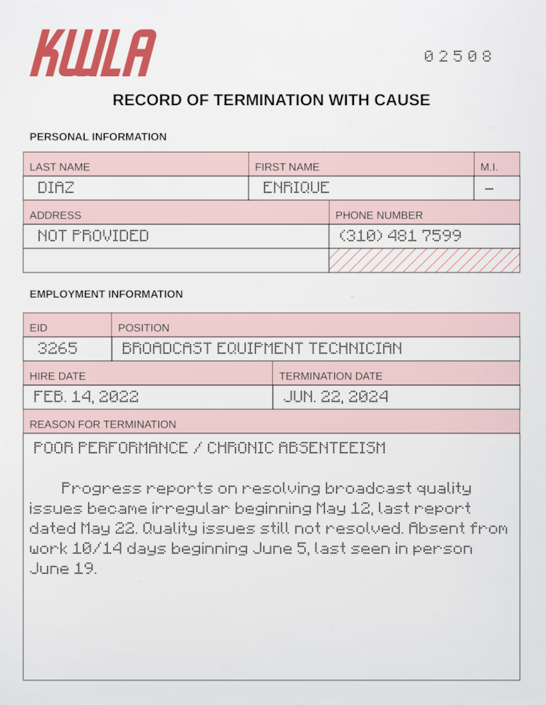

SUGGESTED INSANITIES
- Fear of active televisions, radios, or electronic and media devices in general.
- Obsessive “scanning” of the environment with a smartphone camera or other electronic device.
- Fascination (leading to obsessive study) or aversion (leading to impaired skill use) regarding the discipline of electrical engineering.
- Claustrophobia- this could be portrayed either as the Signal's neurological effect becoming permanent, or the investigator being reluctant to enter spaces where they would be at risk of colliding with an invisible entity.
- Discomfort (or, alternately, fascination) with stars or the open sky, especially if the investigators studied the Signal's origins or read Star Signals.
- Delusions of being watched or stalked by invisible beings, perhaps intending harm to the investigator or their friends.
- Overconfidence in one's own ability to see invisible things, possibly seeing non-existent Echoes or denying that anything the investigator cannot see could truly exist.
- Finally, this first-hand encounter with alien spirits beaming down to Earth and lodging in people’s brains might make an insane investigator very susceptible to the outreach of a certain LA-based religious movement that shall remain unnamed…

THE TERRIBLE DEMISE OF GUS FROM G. E.
Station management grudgingly assents to whatever equipment upgrades are required to clean up the signal, although a Persuade or Charm roll may be required if the investigator handing them the list has been a troublesome employee beforehand. A call is made to General Electric and a new set of hardware scheduled to be brought in next morning- specifically, at 3 AM, when a planned outage will affect the least important programming.
What happens next depends, somewhat, on how the investigators handle that event. Management will not specifically ask them to be present for the delivery and installation –the guy from G.E. will handle all of that– but if a technician asks to be present at the time, assent will quickly be given.

“IT’S NOT OUR PROBLEM…”

ENRIQUE DIAZ’S INVOICE
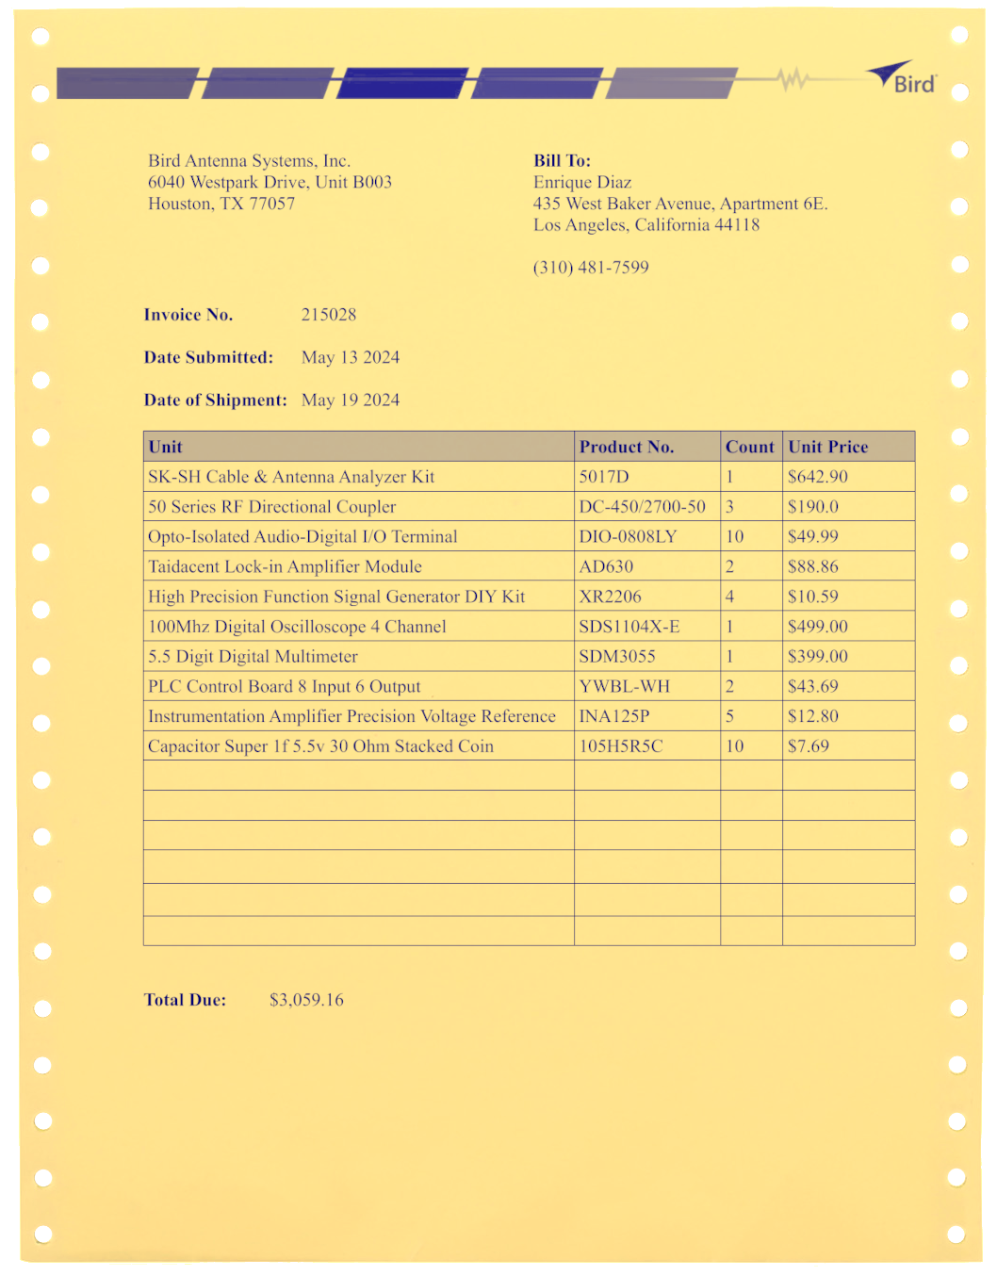

If no investigators are present for the delivery, they arrive at the studio the next morning to find it in a state of chaos. The G.E. technician – ‘Gus’, according to the tag on his uniform – has been found sprawled dead on the electronics room floor, with four long slashes through his abdomen. As with the body in BLINDSIGHT [4], a Medicine roll can confirm that the slashes were not made by a mundane knife or animal claw, but cannot determine exactly what made them. If, however, the same investigator was able to examine both bodies, the wounds are seen to be similar but not identical. This scene also deals 0/1d3 Sanity damage, with an additional 0/1 inflicted on anyone who analyzes the injures.
There is a security camera in the electronics room. If the investigators think to check the recordings, they find the security room (more of a closet, really, with some portable hard drives and a collection of monitors jammed in one corner) unoccupied. Otherwise, management grabs a responsible-looking investigator and asks them to look over the video before it is turned over to the police. Sneaky investigators will need to get in on their own- there is a sign outside, and the door is not locked. The video reveals the following sequence of events:
- Gus starts to work, and spends maybe half an hour installing the equipment and performing basic checks on the studio's power systems.
- He pulls out a small testing device (basically a portable television monitor with hookups that allow it to be connected directly to KWLA's wiring) and begins scanning through the broadcast frequency band.
- He flinches away and curses as the device's screen flashes, dropping a screwdriver he is holding. It rolls some distance away. Zooming in on the security feed and succeeding a Spot Hidden roll will reveal the Signal in all of its sanity-shattering glory on Gus’s screen, but at the default zoom level it is at too low of a resolution to do any damage.
- An Echo appears on the security footage as an area of multicolored garble, between Gus and his screw driver. It moves slightly, placing itself in front of the disassembled power supply unit. He initially ignores it, even walking around it to fiddle with the ventilation unit and get back to the PSU.
- Gus looks either at the screwdriver or the Echo (it is impossible to tell which) before shaking his head as though to clear it.
- He walks forward and intersects with the Echo’s glitchy penumbra. It is not possible to actually see him being carved to pieces aside from a few splatters, as the Echo’s effect is overtop of him. The entire process takes about fifteen seconds.
- The Echo drifts out of the open equipment room door, to parts unknown.
The Keeper may wish to have the Echo still be wandering the building- perhaps it has returned to the equipment room, a nasty surprise for investigators poking around for clues inside. Or, perhaps a Spot Hidden roll detects employees and emergency personnel on the front driveway seemingly unconsciously avoiding one particular spot.
If the Signal is displayed in the security room, an Echo also spawns inside- in the confined space, there is great danger of alarming it. Add up the SIZ of all people in the room, divide by 5, and roll 1d100- if the sum is larger than the number rolled, the individual with the lowest DEX has gotten the Echo’s attention. Recall that all Echoes in the building are copies of one entity:
STUDIO ECHO
STR | CON | DEX | SIZ | INT | POW
60 | 105 | 35 | 105 | 55 | 75
HP | MP | BLD | MOV | DB
21 | 13 | 2 | 8 | +1d6

KWLA SECURITY ROOM

Security
Desk
Pipe System
If KWLA management is shown the footage, they will find it too incredible to believe and ask the investigator who presented it to delete it. It is up to the investigator whether or not to comply with this request; if, instead, the police are shown the footage, they will dismiss it as clumsily edited by the actual killer to conceal what really happened. In either case, Gus was able to finish his work before he met his demise- otherwise, the station would have noticed much earlier that they were still off the air!

“IT IS VERY MUCH OUR PROBLEM!”
If one or more investigators agree to oversee the installation process, events similar to the above occur, but now the investigators have a chance to intervene.
- Gus starts to work just as above. He spends maybe half an hour installing the equipment and performing basic checks on the studio's power systems. Just before he begins the signal quality test, he will ask an investigator to do him a favor, go to the vending machine in the hall, and grab him a soda. He hands them two dollars and says to keep the change. It is up to the investigator if they comply.
APARTMENT ECHOES
 | STR | CON | DEX | SIZ | INT | POW | HP | MP | BLD | MOV | DB
A | 60 | 85 | 60 | 100 | 20 | 65 | 14 | 13 | 2 | 12 | +1d4
B | 95 | 135 | 55 | 70 | 30 | 40 | 21 | 8 | 2 | 11 | +1d6
C | 80 | 95 | 45 | 90 | 35 | 65 | 19 | 13 | 2 | 9 | +1d6

- If nobody stops him, he begins the test. It is possible to use Persuade, Charm, or Intimidate to get him to abandon this step in the installation, but very difficult- make all rolls at Extreme difficulty. If the investigator(s) can come up with a particularly plausible reason for this break in procedure (possibly involving a technical skill roll to know what they are talking about), reduce this penalty to Hard.
- Any investigators in the room when he intercepts the Signal must also roll Sanity or be affected. Gus automatically succeeds his own roll, but still drops his screwdriver (A). At this point, permit remaining investigators to make a second social skill roll using the same penalties as above.
- Anyone looking at the screw driver from the same direction as Gus can see it “disappear” as the invisible Echo (B) materializes in front of it. An investigator who went down the hall returns at this time, and has a good view of the screwdriver fading out of sight as they come in the door. Gus ignores the Echo, even walking around it to fiddle with the ventilation unit and get back to the PSU. He will ask investigators to hold a few components in place while he adjusts the cooling unit, thereby making sure they do not interfere with his path.
- Gus looks at where the screwdriver was, shakes his head, and asks “Did’ja see where that went? Was on the floor right there, but now it's gone.” An investigator in a different location who knows what is going on might think to pick up the screwdriver and pass it to him.
- Gus walks forward and intersects with the Echo. Combat technically begins at this point. That is the last chance for a nearby investigator to beat Gus in the initiative order and pull him away before he interacts with the creature.
- If the Echo is alerted, it proceeds to carve up the hapless technician unless the investigators drive it off. Watching him be shredded in real time deals 1d3/2d4 Sanity damage.
GUS FAIRBANKS
STR  ENRIQUE DIAZ’S NOTES – PART A (ONE OF SEVERAL)  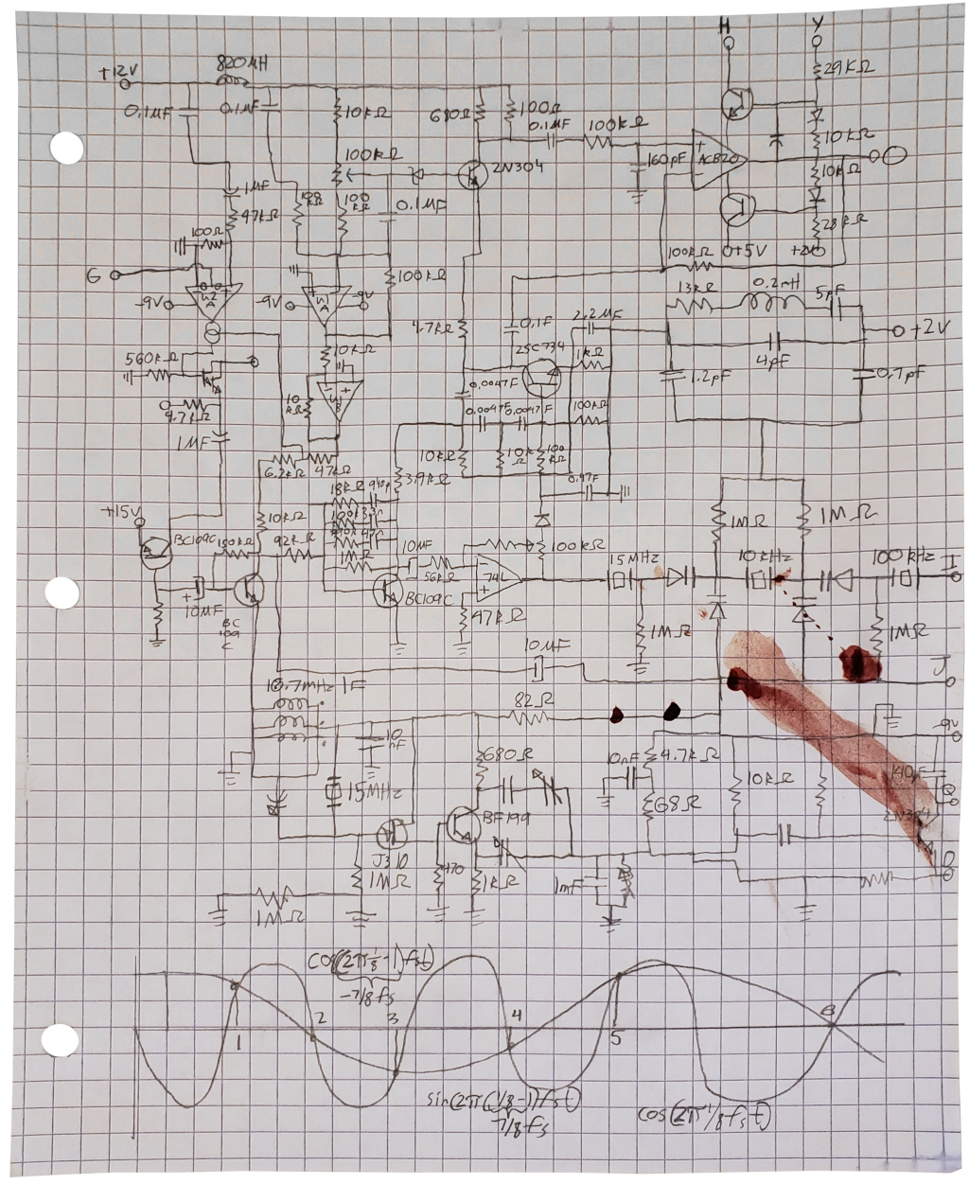  ENRIQUE DIAZ’S NOTES – PART B  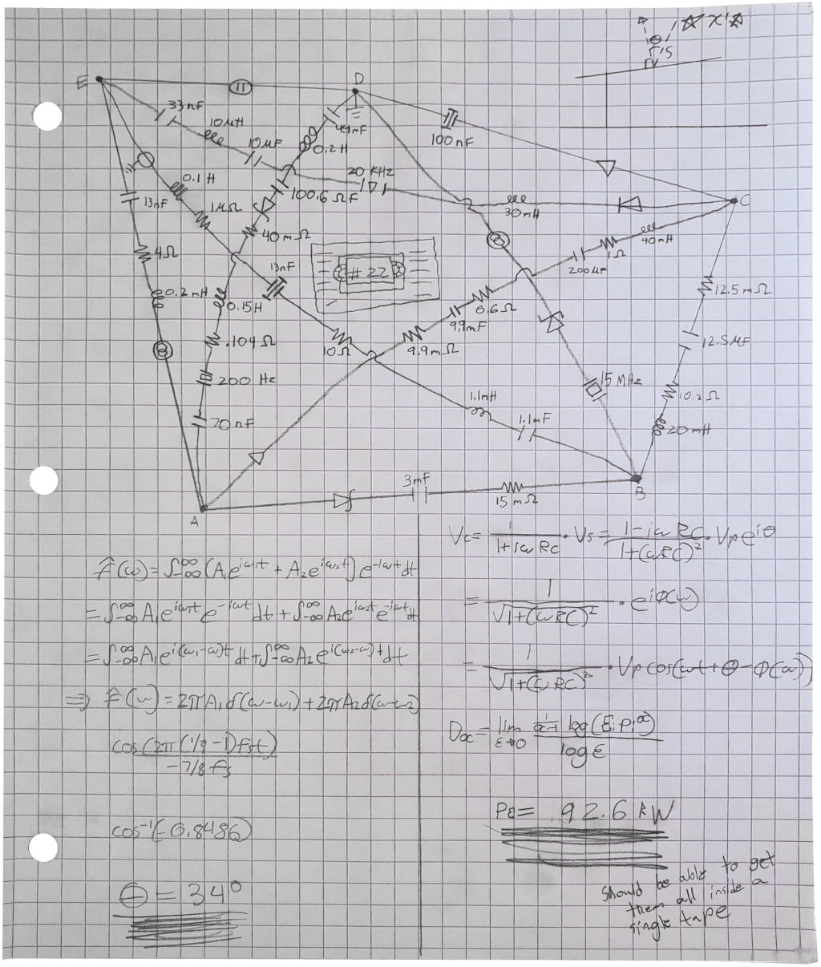  ENRIQUE DIAZ’S NOTES – PART C  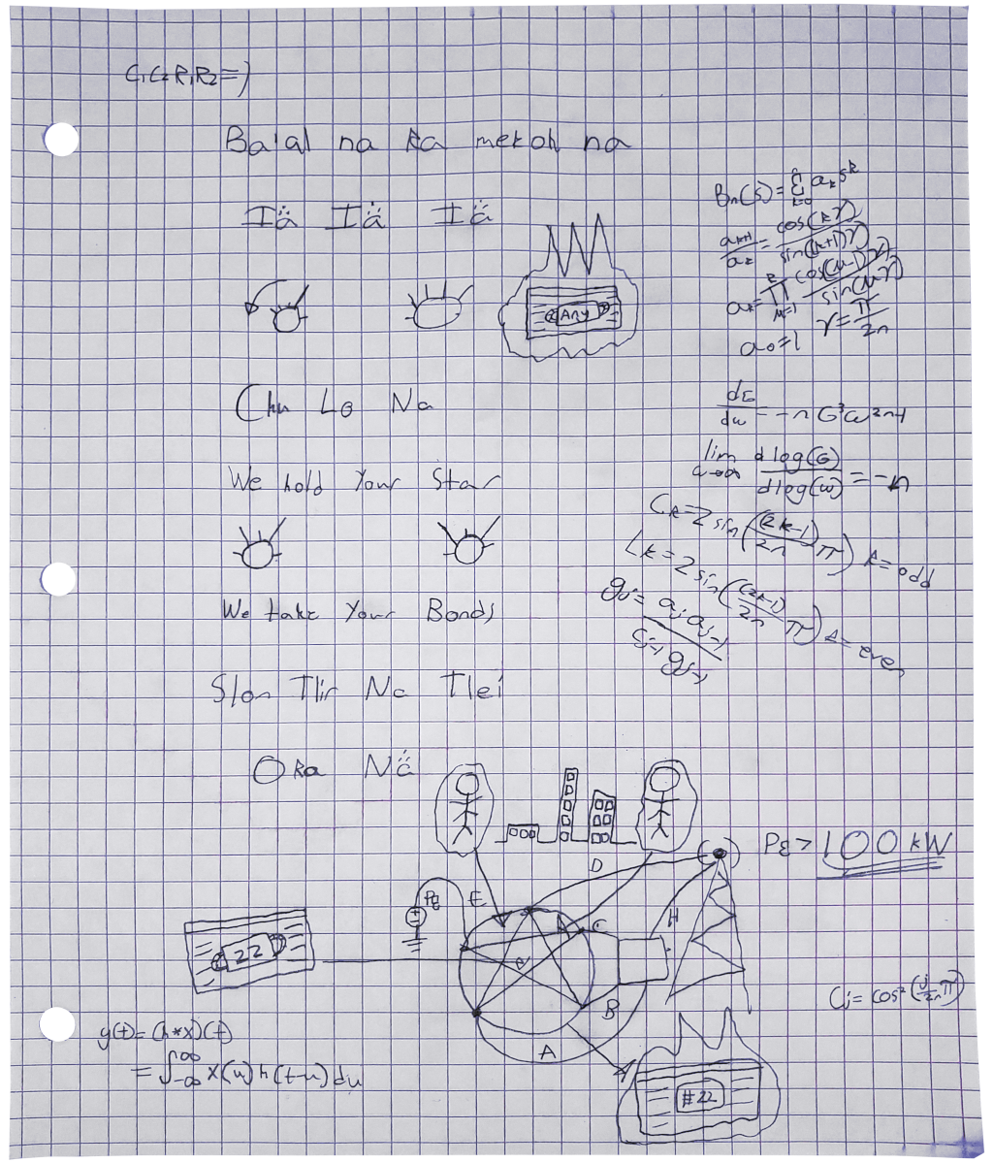 | CON | SIZ | DEX | INT | APP | POW
55 | 50 | 60 | 45 | 55 | 35 | 45
EDU | SAN | HP | MP | DB | BLD | MOV
60 | 45 | 11 | 9 | 0 | 0 | 8

ATTACKS
Cordless Drill:
50% 1x Per Round 1d8

SKILLS
Elec. Repair 70%
Electronics 50%
Listen 40%
Psychology 30%
Science (Physics) 25%
Spot Hidden 60%
Sports Trivia 85%

If at any point the investigator(s) wish to forcibly eject Gus from the hardware room, a Spot Hidden or Operate Heavy Machinery roll notices a halon fire-protection system. Yanking on the fire alarm will cause the room to rapidly fill with poisonous fog, and compel the technician to exit. He won’t be very happy, but an investigator can Persuade him they spotted a spark or small electrical fire.
B
A
Cooling
Unit
P
S
U

KWLA EQUIPMENT ROOM

B
A
Cooling
Unit
P
S
U

THE COVERT OPTION

KWLA ROOFTOP

L
B
A
C
D
This section of the scenario becomes more complex if the investigators are not welcome at the KWLA studio and must sneak their way around. One avenue the Keeper may take is to have KWLA decide to upgrade its equipment on its own, without a dedicated technician on staff to arrange things. If the investigators are surveilling or snooping around the studio at midnight, they may be in a position to assist when the Echo attacks. Otherwise, they hear about the incident on the news next morning, with everyone else.
Another, more drastic action might be to encourage the refit by sabotage. Investigators might also attempt to do this in the belief that taking KWLA off the air will solve the problem of the Signal. This is in fact a very bad idea: KWLA’s viewership will obviously decline, but without KWLA’s broadcast masking it, everyone who does still tune into Channel 6 between midnight and 4 AM will see the Signal. This also won’t do anything about the Echoes already in the city, and the station will also only stay off the air for a few days.
ROOFTOP ECHOES
 | STR | CON | DEX | SIZ | INT | POW | HP | MP | BLD | MOV | DB
A | 75 | 105 | 20 | 125 | 30 | 40 | 22 | 8 | 3 | 6 | +1d6
B | 50 | 110 | 35 | 80 | 60 | 40 | 19 | 8 | 1 | 7 | +1d4
C | 45 | 80 | 20 | 105 | 40 | 45 | 19 | 9 | 1 | 6 | +1d4
D | 60 | 70 | 40 | 105 | 60 | 70 | 18 | 14 | 2 | 7 | +1d6

If the investigators are considering this approach, or have already been to Enrique Diaz’s apartment and don’t know what to do afterwards, the Keeper should include the following email in the studio office:
Kathy:
Having reviewed the original installation contract, it does appear that the replacement policy covers accidental damage and “Acts of God”. It will not be the same system, but a more up-to-date system within our price bracket and form factor. Installation and conversion work will be performed by a company technician.
I hope this is helpful,
-Seth
Checking the online GE catalog with Library Use will reveal that all new transmitter systems available in the studio’s form factor meet Diaz’s 100 kilowatt limit.
Trashing the equipment room with a sledgehammer or a can of gasoline is easy. Trashing the equipment room without getting caught is more difficult- the Keeper may wish for Electrical Repair or Electronics rolls to start an electrical fire, carefully burn out specific components in a manner consistent with wear, artificially generate power surges, drain the cooling system’s refrigerant, or whatever other scheme the investigators can put together. In this case, the investigators have more reason to be present during the refit as they know the time and place, and had a hand in bringing it about.

IT CAN’T BE THAT EASY!
It is very possible that the investigators think they have won by upgrading the transmitter’s power- and, indeed, the active intrusions of the Signal cease at this point. However, this is only a partial fix: the existing Echoes are all still present, and it could take years or decades before they disperse from Los Angeles (do alien ghosts ever die of old age?). If the players don’t realize this for themselves, and show no interest in chasing any of the Diaz leads subsequently presented, triggering a few of the Echo Events from “IF IT BLEEDS, IT LEADS” [4] should be sufficient motivation to get them back on track.

WHITHER DIAZ?
One way or another, the investigators’ work at KWLA should eventually lead them to the name or address of Enrique Diaz, the studio’s former broadcast technician. Mixed Signals was “intended” to be run with THE TERRIBLE DEMISE OF GUS FROM G.E. occurring first, as a gentler and/or creepier introduction to the Echoes and their properties, although the events can occur in any order or even simultaneously with two different groups of investigators. The Keeper should be aware that any mention of Enrique by studio staff or in studio documents are likely to set investigators on his trail, and should be avoided if the original order is to be maintained- but don’t deny these clues to the investigators if they press of their own accord.
There are several reasons why Enrique might not be commonly mentioned. The most significant is simply that very few of the studio staff ever had reason to interact with him: reclusive and spacey, he spent most of his time buried down in the equipment room out of sight and out of mind. He left the bare minimum of contact information required by company policy, and picked up all of his paychecks in person (as opposed to setting up direct deposit or having them mailed). He never got in trouble or made waves, and didn’t make a scene when he was fired. He finally was fired for poor performance and long absences, something many other employees have had happen over the years; his personnel file is indistinguishable from a dozen others without some additional clues to help narrow down the search.
Once the investigators start actively looking, however, more information can be made available.
If specifically asked about “the previous technician”, studio employees can relay basic information about him similar to the above: that he was reclusive, quiet, and a little weird. Some people may have heard “bizarre” noises coming from the equipment room, but assumed those were just distorted television signals (they are not wrong). His wierdness increased dramatically in the month leading up to his firing; people were convinced he came back to the studio late at night to tinker. This information requires no rolls to be made, unless the investigators themselves have been particularly unlikable or troublesome, or are outsiders who don’t have a legitimate-sounding reason to be going around asking questions.
If not questioned directly, employees have a low chance of mentioning anything about Diaz where an investigator can overhear. This chance, however, rises dramatically if something goes wrong with the transmitter system, and is a guarantee if Gus is attacked: “I’m starting to think that basement’s cursed or something. First Enrique flakes out, and now this.” Treat any successful Listen check after the investigators have messed with the transmitter in any way as having a 50% chance of overhearing the remark, and a 100% chance the morning after Gus’s attack.

DELTA GREEN
Mixed Signals may be run as a Delta Green scenario where the investigators and the Feds are one and the same. For the most part, the investigation runs through many of the same beats, although there are a few differences:
- Delta Green agents may have the ability to poke around KWLA legally and openly, without getting hired there, on the pretext of FCC regulatory authority. Since the KWLA section of the scenario is already very freeform, this does not have much of an impact in the grand scheme of things- much of the same information can be found in much the same ways.
- The one option the Agents have which regular investigators don’t is to order KWLA to shut down and stop transmitting permanently, but this is still a very bad idea for the reasons described previously.
- The Keeper may wish to confer the Echoes some resistance to firearms, in order to make them more dangerous to very well-armed investigators.
- The Mysterious White Vans can still be employed as a means of complicating an investigation, as part of a rival agency. Perhaps some black-budget military division or defense contractor is attempting to weaponize the Signal for their own sinister purposes?
- Another option would be to put the Agents in charge of the vans themselves, presumably one or two Agents per van. These mobile command centers / tech labs can be used to perform the triangulations in STUDYING THE SIGNAL [8] or respond to “IF IT BLEEDS, IT LEADS” incidents [4] in real time.
If the investigators have a name, or specifically look for the most recent broadcast technician among the studio’s personnel files, they can find Enrique’s file [21] in about ten minutes of searching. The Keeper may allow for a successful Library Use or Accounting roll to reduce that time by as much as half.

These files are supposed to be confidential, but are not well-guarded. An electronic record (Computers to boot off a thumb drive and bypass the password) and a paper copy in a locked filing cabinet (Mechanical Repair or Locksmith to jimmy) are both located in the HR manager’s office. The office is locked at night (requiring a Locksmith roll) and unlocked but occupied all day. Stealth is required under normal circumstances to get past any people outside, but if something catastrophic happens (like Gus’s death, or an investigator-orchestrated problem in the equipment room or elsewhere) the whole office block clears out to go and gawk. Investigators with law enforcement credentials can also access the files with probable cause, or investigators could even use Persuade/Intimidate and Law to convince the manager that they are tax auditors or other authority figures.
If the investigators just have a name and no address, they can attempt to look up a location in the White Pages. Unsurprisingly, there are quite a few Enrique Diazes living in Los Angeles, but with 3d6 hours’ worth of legwork (divide the total time evenly between all investigators performing the search) it is possible to track down the right one- as will be shown in the following section, they will know him when they get to him.
Calling the phone number on the file informs the caller that the number is not in service. Enrique took his phone apart and incorporated it into his project, and was leaving his phone bills unpaid for a while before that.
A search for any other documents with the name “Enrique Diaz” will reveal an invoice containing Diaz’s address [23], perhaps tucked away under the front desk or in the equipment room itself. A “nuclear option” might be to have it slip out of one of the equipment racks when Gus the technician is upgrading the broadcast system (or when the players themselves are looking around after his untimely death [15]).

ENRIQUE DIAZ’S APARTMENT

GETTING IN
From the street, it is possible to see only that the curtains of the apartment are drawn and the balcony doors are closed. Faint light is visible through the windows at all times (requiring a Spot Hidden roll to notice in the daytime). The building manager, a heavyset older woman named Stacy Sykes, greets any visitors gruffly. A successful Charm or Persuade roll is necessary to get her to open up about the tenant in Apartment 6E, and what she has to say isn’t kind:
Oh. That creep. Weaselly little guy. Worked at a TV studio or something, I think, he didn’t talk much. Came and went at all hours of the night. Couple times I saw him go up with a roll of copper wire or some big piece of stereo equipment under his arm, or a computer, or a TV. I reckon he was ripping it off to feed some drug habit… he had that spaced-out look in his eyes. Played the most Godawful eee-lec-tronical music sometimes, too… Didn’t sound like no music I ever heard. I reckon he skipped town a while ago, ain’t seen him in two weeks. If you find him, you tell him he still owes me last month’s rent! Ran up his electrical bill somethin’ fierce, too.
Mrs. Sikes puts up token resistance if the investigators ask to be let inside the apartment. She’ll ask police or other authority figures if they have warrants, but still let them in even if the answer is ‘no’. Her response to most general Persuade attempts is to tell the investigators to fuck off, but will accede if given a bribe- even as little as $20. Another tactic is to claim that Diaz owes the investigators money- if they look even remotely like gangsters (tattoos, bandannas, jewelry, or for that matter even nice suits), she’ll back down. She will also immediately proceed to “evict” Diaz if the investigators express any interest in buying the apartment. They don’t need to go through with the deal- once the interior is revealed, Sikes will have other things on her mind.
Alternatively, investigators may just wish to break in. A Climb roll scales the fence outside; another can be used to reach the balcony, or the investigators can just take the outside stairs. The front and patio doors are both locked, but can be picked; or the investigators can just break the glass on the patio door with a tool or an unarmed attack.

INSIDE THE APARTMENT
The very first thing the investigators notice about the apartment is that it is extremely hot inside. The next is the glow. Diaz has laboriously stapled strings of lights over every inch of the walls, floor, and ceiling- some are commercial Christmas lights, while others appear to be homemade from copper wire and LEDs. The pattern is crazy and disorienting- anyone stepping inside takes 0/1 Sanity damage. A successful Science (Astronomy) roll identifies the pattern as stars; specifically those viewed from χ¹ Sagitarii. If an investigator has previously failed a Sanity roll due to exposure to the Signal [3], the pattern looks suddenly, terrifyingly familiar: the Sanity loss is instead 1d3/1d6, and no skill check is necessary to understand exactly what it signifies. Failing this harsher Sanity roll also brings on an attack of claustrophobia.
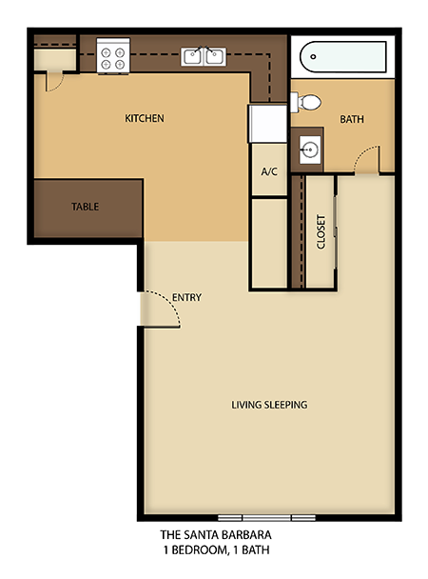
An electrical workbench occupies most of one wall, covered in textbooks, diagrams, components, and scrap wire- it hasn’t been used in a long time, as now Enrique’s workbench is the whole apartment. The floor and shelving units on the walls are strewn with wires and disassembled electronics- much of it is running, the source of the intense heat. An Electronics or Science (Physics) roll identifies amplifiers, filters, analog-to-digital converters, function generators, and other laboratory and communications gear intermixed with purpose-built devices of unclear function. More books and loose pages are also scattered around the area. Examining them reveals them to be calculations, schematics, technical papers, and excerpts from electronics texts.

DIAZ’S APARTMENT

B
A
Shelf Unit
Workbench
Shelf Unit
TV &
Body
C
The equipment all condenses into a “nest” of wires taking up much of the center of the room. The body of Enrique Diaz crouches in the center, wearing a white T-shirt and jeans, quite dead. His head is jammed inside the shattered picture tube of an old Trinitron CRT television in front of him; dried blood is still visible trickling from a slash wound across his neck and on one of the protruding shards of glass. The hot and dry conditions of his apartment have effectively mummified him; there is little smell of decay. This bizarre and unsettling sight deals 1/1d6 Sanity damage.
The front panel of the Trinitron has been pried off, and some of the circuitry inside replaced. Another Electronics, Science (Physics), or Science (Astronomy) roll indicates that the TV has been modified to receive “between” the standard broadcast channels- the forbidden Channel 37 [9].
The most important elements here are several piles of VHS tapes stacked up against the TV; and one book and a sheaf of papers sitting beside Diaz’s body, clearly set apart from the room’s general clutter sometime before he died. No roll is required to notice them. The papers and the tapes are discussed in the subsection FRUITS OF A MISSPENT YOUTH [26].

HIDDEN DANGERS
The Trinitron’s picture tube is destroyed, and that damage tripped the surge protector it is plugged into. However, the speakers still work- if the investigators are foolish enough to reset the surge protector, the TV will start playing the Signal. A claustrophobic attack in here would be bad news- the balcony leads to a three-story (3d6 damage) drop.
Moving about in the maze of wires in the center of the apartment is difficult- reduce movement speed to one third.
Three Echoes also share the apartment with the late Mr. Diaz. A and B sit on either side of the patio doors. C is standing directly over Diaz’s body. Due to the amount of clutter in the apartment, the “blank spots” they produce can be discerned with a Spot Hidden roll. Once the investigators are aware of their presence, it is possible to move past them (for instance, to grab the tapes and papers) with a DEX roll. Clever investigators might also improvise some kind of grabber-on-a-pole device to recover the materials without putting themselves in danger.
The last, and most significant, threat in the apartment is that it is a massive firetrap: hot, dry, and stuffed with paper and live electrical equipment. Any attacks that miss their targets hit the walls, floor, or piles of junk. If a d100 roll comes out less than the damage dealt, whatever was struck sparks and catches fire. The Keeper may also wish to roll against Sanity damage dealt when someone suffers a claustrophobic fit, to represent the investigator charging pell-mell through the debris, yanking out wires and knocking things over.
A spark becomes a localized fire one round after it occurs. Three rounds after it occurs, it has spread to half the room and is no longer possible to control with fire extinguishers; smoke inhalation is a serious issue (treat as drowning for anyone who didn’t bring breathing protection). Six rounds after a spark, the fire has spread to the whole room. The Echoes do take fire damage, but don’t acknowledge they have been hurt: if nothing leads them out, they will stay in the room until they are completely incinerated.

THE FRUITS OF A MISSPENT YOUTH
The VHS tapes in Enrique Diaz’s collection are all identical in appearance, and have hand-written labels with consecutive numbers: from #1 up to #37. If the investigators cannot take all of them (for instance because Echoes are chasing them or because the room is on fire, or both), the Keeper should make sure one of the ones they do acquire is #22- it’s important for the finale. Depending on when the scenario is set, just finding a functional VHS player to read the tapes might be a minor adventure in itself, and perhaps that’s for the best: they, of course, all contain nothing but the Signal.

The book is the Mythos text Star Signals [37]. Its incomplete SUMMON/BIND spell is highlighted.
The first dozen or so pages of Diaz's handwritten notes (collectively referred to as “Part A” [27]) contain schematics of a standard FM radio transmitter, filter, amplifier, and other devices, identifiable by Electrical Engineering or Electronics, but they are modified in bizarre ways. Equally bizarre is the “antenna” in Part B [28]. An Electronics or Physics roll suggests that the completed device performs many standard operations on signals passing through it -modulation, frequency-shifting, and the like- with no clear purpose. An Electronics, Electrical Repair, or Science (Physics) roll also calls attention to the equations in the margins, and the underlined power requirement: 100 kW. Cthulhu Mythos recognizes the antenna as resembling an Elder Sign; Occult rolls can simply identify the significance of the pentagram in summoning and protective magic. Navigation or Science (Astronomy), or even an INT or EDU roll if all else fails, can identify the symbols on the star in the corner as reading “χ¹ Sagitarii” if the players do not deduce this themselves.
Part C [29] contains a sequence of bizarre syllables and gestures- this is the spell SUMMON/BIND ECHO, although the investigators won’t necessarily know that until they try it out. If they know a SUMMON/BIND spell already, make a Cthulhu Mythos roll, or can reference the incomplete one in Star Signals, it is recognizable as of the same type.

FINALE

PREPARATIONS
Based on the contents of his notes, the investigators should be able to realize that Diaz’s transmitter spell is capable of drawing in the Echoes now infesting Los Angeles.
Putting together the equipment requires only time, knowledge, and commercially-available parts- about $250 worth. As with the Signal analysis earlier in the campaign [8], allow each investigator working on the device to make one Electronics, Science (Physics), or Electrical Repair roll every 2d4 hours. Then, add the D100 result of each successful roll to a common pool representing the total progress made on the assembly. When the pool reaches 300 skill points, the equipment is complete. If Diaz’s apartment survived and the investigators have free access to it, reduce this limit to 150 skill points, as much of the equipment there is related to the device and can easily be cannibalized. The Keeper should feel free to have additional Echo-related incidents occur throughout Los Angeles [4] if the investigators take more than a few days to do this.
Confusingly, although the exact dimensions of the “Elder Antenna” mechanism do not matter, as the investigators assemble it they will note that the electrical properties of the device change drastically; depending on if it has the proper topology or not (for instance, if Point E were moved to the other side of the wire running from A to D- a change that should have no effect on the underlying electrical circuit). This weird phenomenon might be helpful in determining whether the system is “working” or not.
Finally, there is the matter of the 100kW transmitter necessary to power the mechanism. These devices are big and clunky, and require complex infrastructure to support- not something the investigators can just buy and set up in a parking lot. Fortunately, KWLA has exactly the equipment the investigators need, or soon will. If the investigators have not examined the studio in detail before and go poking around, this is a good time for the Keeper to drop the transmitter’s replacement-policy documents- or, in the interests of expediency, decide KWLA already has the equipment necessary and dispense with THE TERRIBLE DEMISE OF GUS FROM G.E. [15] entirely.

PERFORMING THE RITUAL
Installing and preparing Enrique Diaz’s box of tricks requires several easy and safe changes made down in the KWLA equipment room (or, perhaps, not so easy, if the investigators must enter covertly and sneak around). Unless an Electrical Repair or Electronics roll is fumbled, the station is not taken off the air. However, the antenna and “magic box” must then be brought up to the transmitter hookups on the studio’s roof, and several additional steps performed:
- The investigators will need to set the Elder Antenna up pointing 30° south of χ¹ Sagitarii, and put the tape in the center. Aiming it correctly requires a single Science (Astronomy) or Navigate check. Thoughtful investigators will have completed this step before doing anything that might annoy the Echoes on the rooftop.
- One end of the Magic Box will need to be hooked up to a transformer power supply on the roof.
- Another set of connections will need to be made between the Box and the Elder Antenna, and the antenna tower elsewhere on the roof.
The studio roof is split into four sections, two elevated ones on either side of a central area, with a further elevated level on top of the left-side one. All are connected by sloping segments of the roof's tar paper construction; additionally, a ladder ('L') connects the first and third-level left-side areas. Although investigators needn't fear losing their footing on the rough, dry surface, should they be pushed or step back from an inappropriate position there is only a low cinderblock lip between them and a three-story (3d6 damage) fall. The Keeper may allow a DEX or Climb roll to grab on or avoid being pushed over.
The power box is highlighted in yellow. It requires two successful Electronics rolls or four Electrical Repair rolls to properly reconfigure it and splice in the Magic Box; one roll may be made per round. However, an Echo ('B') is staring fixedly at it; anyone looking at the box will be able to see the details on it disappear without making a roll. A very small and nimble investigator might be able to slip between it and the target without touching it by failing a SIZ roll with a bonus die, and then succeeding at DEX rolls for every turn spent working at the box. It might also be possible for the investigators to draw the Echo away with violence, or with something more complicated and interesting than the box.
It is also necessary to scale the transmitter tower by climbing it. The tower is 9 feet (three squares) tall. It has a ladder that can be scaled normally under peaceful conditions, but in combat a Climb roll is required to move at any rate higher than 3 feet (one square) per round. The investigator will only fall off if they fumble or fail a pushed roll. Additionally, anyone looking at the tower will be able to see that there is an Echo ('A') already anchored midway up the superstructure. It is possible to avoid it by climbing the superstructure on the other side of the tower- this requires three Climb checks even outside of combat, and in combat they are made with a penalty die. The investigator can then attempt to work around the Echo in the same manner as above: failing a SIZ roll with a bonus die, and succeeding at DEX rolls for every turn spent working at the antenna. The Echo also will fall to the ground if shot or even simply pulled from its current position (roll two STR checks- if both succeed the Echo is dislodged successfully, but if both fail the investigator is pulled to the ground with it). Readjusting the transmitter equipment takes two Electrical Repair rolls or one Electronics roll.
It is possible for someone at a safe distance to talk an investigator on the tower or in front of the electrical box through their rolls and make them from safety, but if the player physically working on the antenna does not have at least 50 in Electrical Repair or Electronics this process takes twice as long (two turns per roll instead of one).
Two other Echoes (C and D) lurk on the corners of the rooftop, but will only attack if alerted. A particularly aggressive Keeper might have any of the steps irreversibly anger all of the Echoes in the area simply by performing it.
Once the modifications are done, all that an investigator needs to do is switch on the box.

ONCE THE RITUAL IS COMPLETED
An eerie electrical hum fills the air. As a coordinated unit, all Echoes in the studio pause in their activities and proceed to the antenna, followed by more and more from all over the city. Soon, their numbers make them clearly visible as a shimmering distortion in space. One by one and then in groups, they fade from view as they approach the tape, which glows with a bluish, phosphene-like aura. A pulse of electromagnetic energy generates interference in the 612 MHz band all across Los Angeles- peering through the static on televisions tuned to Channel 36, a hunched, four-armed entity is briefly visible, staring out with glittering compound eyes. Investigators looking to the sky may notice Chi Sagittarii briefly flash bright blue before the assorted unearthly manifestations fade away once and for all. The entire process takes a little under five minutes.

OPTION: THE FEDS
If the Keeper wishes to add another dimension of difficulty and intrigue to the scenario, or alternatively to provide the investigators with some degree of backup (however unintentional), it is possible that the authorities also take an interest in the Signal and its effects. These meddlers can show up at inopportune moments to provide a more mundane obstacle to investigators who are moving quickly; or alternately to drop hints, or charge in and take some of the heat off of the investigators if a particular combat is going badly; or just to add atmosphere.
The initial response takes the form of unmarked white Ford vans with US Government license plates, topped with electronic equipment. They trawl the streets of LA, attempting to locate and gather information on the Signal: each contains one electronics technician, and two armed men in dark suits. The technician possesses an FCC identity badge; both of the armed agents have FBI credentials. If the investigators are somehow able to run the IDs, they all check out as legitimate.
The investigators are likely to encounter the vans while out investigating the Signal or Signal-related incidents. Perhaps they serve as an additional complication that the investigators must avoid. Conversely, the Keeper might allow struggling investigators to come across a crashed van that ran afoul of an Echo, and scavenge materials or clues they had previously missed from it before reinforcements arrive. Having the vans start to seem to follow the investigators as they drive around the city is a good way to creep them out and establish the Feds’ presence without committing to any definite course of action.
The vans’ inhabitants might also take an active interest in KWLA, crime scenes, or Enrique Diaz’s apartment. They will wade in brandishing badges, displace the local police, and demand to see evidence or ask people questions. This can be used in a number of ways:
- The Feds can, of course, complicate investigator visits by adding another layer of security and generally shaking things up.
- Conversely, these visits might provide hints to stuck investigators- whether because they tracked a van to a location they had previously missed, or because they overhear an NPC being questioned about certain topics in the next room.
- They can chase after investigators who have decided to do anything particularly catastrophic or with a high likelihood of making the supernatural public. In addition to hushing up the incident itself, they can be used to deliver a warning to insufficiently-discreet investigators. The offender wakes up in the back of a van with their hands zip-tied behind them, is questioned in detail, then told to forget all about alien ghosts coming through the TV set, before being released. After such a warning, the Keeper should feel free to bring the hammer down on investigators who continue to make trouble: they could be arrested on trumped-up charges, involuntarily and indefinitely committed to a psychiatric institution, or simply disappear.
- Alternatively, the Feds might charge in if a combat encounter is going particularly badly, and provide a welcome distraction by which the investigators can escape with their lives.

SAMPLE FCC TECHNICIAN
STR | CON | SIZ | DEX | INT | APP | POW
35 | 40 | 50 | 50 | 80 | 40 | 55
EDU | SAN | HP | MP | DB | BLD | MOV
75 | 55 | 8 | 11 | -1 | -1 | 7

ATTACKS
Glock 17 Sidearm:
40% 1x Per Round 1d8

SKILLS
Accounting 60%
Computers 70%
Elec. Repair 90%
Electronics 80%
Listen 60%
Science (Astronomy) 50%
Science (Physics) 70%
Spot Hidden 40%

SAMPLE FBI AGENT
STR | CON | SIZ | DEX | INT | APP | POW
65 | 55 | 60 | 50 | 55 | 50 | 45
EDU | SAN | HP | MP | DB | BLD | MOV
65 | 45 | 12 | 9 | +1d4 | 1 | 9

ATTACKS
Glock 17 Sidearm:
70% 3x Per Round 1d8

ARMOR
Kevlar Vest +4

SKILLS
Accounting 50%
Dodge 60%
Fighting (Brawl) 75%
First Aid 30%
Intimidate 70%
Law 60%
Listen 80%
Persuade 50%
Psychology 80%
Spot Hidden 80%
Stealth 60%
Track 70%

The first group of Agents attempting to go up against Echoes will have nothing but their sidearms and all-American grit. This will likely not end well for them; afterward, all of the vans include an additional four-man fireteam in unmarked black SWAT-style tactical gear, armed with grenades and assault rifles. One in every four-man squad carries a shotgun instead of a rifle. A very generous Keeper might also give them modified night-vision goggles that are able to detect the Echoes’ interference.

SAMPLE BLACK-OPS
STR | CON | SIZ | DEX | INT | APP | POW
70 | 75 | 70 | 70 | 40 | 30 | 50
EDU | SAN | HP | MP | DB | BLD | MOV
60 | 50 | 13 | 10 | +1d6 | 1 | 9

ATTACKS
Glock 17 Sidearm:
80% 3x Per Round 1d8

AR-15 Assault Rifle:
70% 3x Per Round 2d8

Mossburg Automatic Shotgun:
70% 3x Per Round 4d8/2d6/1d6

Hand Grenade:
60% Carries 2 4d6/4yrds

Combat Knife:
80% 2x Per Round 2d4+2

ARMOR
Plate Carrier +8

SKILLS
Climb 60%
Dodge 80%
Fighting (Brawl) 80%
First Aid 50%
Intimidate 30%
Jump 60%
Listen 80%
Sneak 70%
Spot Hidden 80%
Track 70%

Assume the Feds can employ sophisticated methods of surveillance and are running their own investigation. Thus, they can appear at any convenient moment- although if the Keeper intends to use this option, it would be advisable to include a few van sightings early on to avoid a complete deus ex machina.

CONCLUSION
If the investigators are able to drown out the Sagittarian Signal, award them 1d4 Sanity points, as well as one point for each Echo they have destroyed (up to a maximum of 6 points).
If the investigators not only suppress the Signal but also complete Diaz’s ritual, then the reward is instead 1d8 + 6 Sanity points (as they have ‘defeated’ every single Echo on Earth).
Saving Gus From G.E. from his terrible demise is worth another 1d3 Sanity points.
If the investigators fail to do any of these things, the Signal cuts off of its own accord after a few months when the last radio transmitters on χ¹ Sagitarii V fall silent. By that time, of course, the city of Los Angeles is positively lousy with Echoes- its soaring crime rate pushes it into an economic decline from which it never recovers, and within a decade the film and tourism industries have fled downstate to San Diego or up to Seattle and Vancouver. Inflict an additional 1d8 Sanity loss whenever appropriate.
If the investigators caused anything catastrophic to happen (such as broadcasting the Signal in its pure state to all of LA), inflict a further 1d10 Sanity damage.
No specific Sanity penalty is listed for allowing the “IF IT BLEEDS, IT LEADS” attacks to accumulate, as they do Sanity damage in the course of their investigation. However, if the investigators did not visit the scenes or otherwise ignored them, the Keeper should feel free to assign the damage anyway at the end of the scenario- by working more quickly, the investigators could have saved some innocent lives.

MYTHOS TEXT: STAR SIGNALS
SANITY COST: 1d4/1d6
CTHULHU MYTHOS: +8
LANGUAGE: English
STUDY TIME: 1 Week

SPELLS
None, but adds 2 to the Spell Multiplier of any Summon, Call, or Dismiss spell from another source.

PHYSICAL DESCRIPTION
A 220-page, B-format paperback printed on cheap-quality paper. The front cover is navy blue, contains the title and author's name (“Jack Claire”) in raised gold lettering, and features a painted rendition of the constellation Virgo. The back cover lists the authors as “Jack Claire with Ashley Space”, and features several blandly positive reviews from D-list celebrities: “Star Signals turned my life around”, “If you must read one book this summer, read this one,” etc. Text inside is in ordinary 12pt., Times New Roman font, without illustrations.

HISTORY
Published in 1997 through Rodale House, a small producer of self-help and diet books; the only printing encompassed 2,000 copies and was largely confined to the American West Coast. The book fared extremely poorly due to its almost nonexistent marketing, and many unsold copies were returned to the publisher to be pulped. Jack Claire, a failed motivational speaker based out of central California, died of a massive drug overdose in September 2001. The whereabouts of “Ashley Space” are unknown.

PROVENANCE
More obscure than it is rare, Star Signals might be encountered in the bargain section of any used-books store, especially one that specializes in “touchy-feely” or New Age topics. It is still somewhat more common on the West Coast of the US than anywhere else, and highly unlikely to be found in non-English-speaking countries. It is of no interest to historians or serious occultists. Some copies in circulation are “stripped”- their front covers are removed, indicating that they were intended to be pulped. These are more likely to be found at flea markets, thrift stores, and charity libraries.

CONTENT
Star Signals would broadly be described as a self-help book with heavy New Age overtones, describing a “name it and claim it” wish-fulfillment strategy based around astrology and meditation. The writing is straightforward modern English and somewhat simplistic. The style is similar to an informal instruction manual, albeit with frequent first-person philosophical and anecdotal digressions by the author. Although the later chapters occasionally feature unusual and disturbing subject matter, the tone remains relentlessly positive throughout.
The book is divided into twelve chapters named after the signs of the Western Zodiac, with the majority of Mythos content being located in the last five. Structural principles of magic are described through the lens of affirmations and mantras, extrasolar Great Old Ones are described in reference to the stars they inhabit, and the Elder Gods are mentioned in passing along with the Elder Sign (referred to as a “stellar dream-catcher”). One of the “mantras” is an incomplete Summon/Bind spell targeting no specific entity; its structure can be used to increase the chance of successfully learning other Summon, Bind, or Dismiss spells.

EXCERPT
Chapter 3, 'Gemini’
Section 5, 'You are in Tune'
Star Focus: Find your night spot and begin to focus on Fomalhaut. As you stare up into it, use your mind-clearing word. Your meditation is: 'Slon tlir na tlei obr thei. Now is our time. Here is our space. We take your star. We hold your bonds. Repay your debt. Slon tlir na tlei obr thei.' Don’t worry about memorization; any time you use your mind-clearing word, you’ll remember the mantra, even if you only read it once. If you do it right, Fomalhaut will flash orange. You’ll always have it resonating with the others in your Personal Library whenever you need that little something extra to get through your day.

CREATURE: ECHO

 | ROLL | AVG.
STR | 4D6 × 5 | 60
CON | 4D6 × 5 +30 | 100
DEX | 2D6 × 5 | 35
SIZ | 4D4 × 5 + 4 | 18
APP | e^{sin(-πd1.3)} | √-🙃
INT | 2D6 × 5 | 7
POW | 3D6 × 5 | 14

SANITY LOSS
Becoming aware of the “blind spot” caused by an Echo does 0/1d4 Sanity damage- when that blind spot begins attacking people, deal an additional 0/1d6 the first time only. When viewed through an electronic device as interference, Echoes do no Sanity damage when passive and 0/1d6 when aggressive.

ATTACK DEFLECTION
Attacks made against Echoes are normally at one half of the usual skill. Viewing an Echo through an electronic device like a camcorder reduces the skill penalty to 1d20 percentiles.

CLAWS
Echoes can make 4 claw attacks per round, each at 60% for 2d4 damage. These attacks can all be directed at the same target, or against four different targets, or any combination in between.

MOVEMENT
Echoes possess a jittery, stop-motion sort of movement: they change position all at once, then freeze in place for a moment, then change position again, then freeze again, and so on. When not doing anything, they remain utterly still. They can “flash” a maximum distance equal to their DEX / 5 + 1 per round. Each section of movement that can be accomplished as a straight line is instantaneous: the Echo does not at any point occupy the intermediate spaces on its path. They cannot pass through solid objects.

Echoes are invisible, inscrutable remnants of the highly sophisticated civilization that once inhabited the planet χ¹ Sagitarii V. They may be the literal ghosts of the Sagittarians, or some distorted remnant of the species resulting from a failed attempt to “beam” themselves to a new home, or something else entirely. Whatever their nature, they retain only a fraction of their original intelligence and are highly aggressive if provoked.

ORIGINS
Echoes are carried along in the Sagittarian Signal, alongside other miscellaneous data utterly incomprehensible to humans. Whenever the Signal manifests strongly and is intercepted by a human receiver, an Echo is spawned nearby. Recording a section of the broadcast and playing that recording back multiple times will create multiple “copies” of the same Echo over and over again.

BEHAVIOR
If left alone, Echoes are generally docile and fairly curious- they will often sit in one place and “watch” sophisticated electrical equipment or humans performing complicated tasks, and when χ¹ Sagittarii is visible tend to gravitate to areas with a good view of the sky (such as rooftops).
However, the entities will respond violently to any attempt at interaction by humans. Touching an Echo, hitting it with an object, or even speaking directly to it will cause all Echoes in the area to attack and attempt to kill whoever disturbed them. Other humans in the area will be ignored unless they intervene. It should be noted that acknowledging the existence of an Echo is not sufficient to provoke it, and the creatures are smart enough to distinguish between speech referring to themselves versus speech that could be considered as provoking a response. Echoes do eventually lose interest in their quarry, but only after their electromagnetic senses can no longer detect them for an extensive period of time- at least several hours.

HUMAN OBSERVATION
The not-quite-matter making up an Echo is solid enough, but has bizarre optical properties. Although the eye can physically perceive it, the human brain immediately rejects such nonsensical input, rendering Echoes effectively “unseeable”. The effect is similar to that caused by a visual blind spot: no “hole” or obvious sign of missing visual information can be perceived, and instead the area is simply covered over by whatever textures surround it. Against a flat background such as the sky, Echoes are more or less invisible, although if they get between a viewer and a small or complicated object (such as text on a sign or an electrical outlet) the viewer may notice that detail suddenly “disappear”. This may call for a Spot Hidden roll, after which the Echo’s location is revealed.
Although humans cannot normally see Echoes, viewers remain subconsciously aware of them and will naturally walk around the creatures to avoid collisions. This ability may be disrupted if the subject attempts to walk through a space not much larger than the Echo, or if the subject is made consciously aware of what they are doing.
Nonhuman creatures with conventional eyes (including Deep Ones, Ghouls, and most animals) are affected by Echoes identically to humans- animals in particular tend to instinctively avoid areas with Echoes in them. Creatures like the Mi-Go that perceive visible light by means other than eyes may see Echoes as they really are, experience intense pain upon looking at them, or not see them at all. Looking at an Echo does not normally cause any lasting damage to the visual system, but using a lensed optical instrument such as a telescope might amplify the effect to the point where it becomes painful.
Any attack rolls made against an Echo when perceiving it as a blind spot are made at half normal skill.

MECHANICAL OBSERVATION
These same optical properties act in an intensely negative manner upon cameras and other light-sensing devices. Viewed on digital or analog media (including live closed-circuit displays), Echoes appear as an area of colorful “noise”, taking up either an oval space or a series of “blocks” (in electronic devices) of the same general shape as the creature.
Although this effect certainly provides more concrete information on where an Echo is than looking at it unaided, it is also awkward to be carrying around a smartphone everywhere in combat. Therefore, any device used to view an Echo has a (1d20)% aim penalty associated with it.
Very simple mechanical devices such as motion detectors that activate whenever something within their sensor field changes will detect Echoes successfully. Recording an Echo for too long in the same area of a camera's field of view might cause permanent damage to the photosensitive element, producing permanent interference in that area of the screen.

PHYSIOLOGY
Although Echoes do not cast shadows, it is possible to acquire information on their structure through non-visual means such as sonography or plaster casting. This will reveal a bipedal creature with four upper arms ending in bird-like claws. Their feet are trefoil-shaped, with pronounced ball-like structures on the underside of each toe. Echoes typically walk on their legs and first pair of arms, hunched over like a gorilla, although they can stand up on two legs and use all four arms to attack. Seeing the shape of an Echo made manifest deals 0/1d6 Sanity damage.
When killed, Echoes do not leave behind physical remains- instead, the dimensional fold they generate contracts and the creature simply vanishes.

SPELL: SUMMON / BIND ECHO
MP COST: Variable
SAN COST: 1/1d6 – The Echo that appears may do more Sanity damage
CASTING TIME: 30 seconds

This spell causes a Sagittarian Echo to appear and follow simple plain-language instructions. Summoned Echoes can be given commands of an indefinite duration, however if an Echo is interacted with by a human or other living thing, it will revert to its “natural” behavior and attempt to eliminate the distraction. If the command was finite in nature, the Echo will resume trying to accomplish it after being distracted; otherwise, it will “forget” what it was told to do and wander aimlessly.
The spell requires the presence of an analog or digital recording on which an Echo-producing portion of the Sagittarian Signal has been copied. If the star χ¹ Sagittarii is visible in the sky when it is cast, the recording is not harmed and can be used again; if χ¹ Sagittarii is not visible, the recording becomes blank.
The magic point cost of the spell is variable- each point expended increases the percent chance of a successful summoning by 5 percentiles, although a roll of 94-00 is always a failure.

AUTHOR’S NOTES
In a very early draft, the Echoes of Signal to Noise were called Wraiths. They were (somehow!) created every time an “if-it-bleeds-it-leads” news story was broadcast, so they would sneak around invisibly and cause accidents in the hope of creating more news.
I think the less silly direction I was planning to take them was more in line with how the Echoes actually wound up being produced- any recording of a Wraith, if replayed, would create more, so the Wraiths would cause accidents simply because that was the best way for them to get themselves on camera and on the largest number of screens. As the name implies, their appearance was largely inspired by the Wraiths from Puella Magi Madoka Magica. Those had a very effective “don't look directly at it” interference graphic over their eyes that the available screenshots really do not do justice.
Eventually, however, the accident aspect of the creatures was largely dropped, and I wound up taking what was left over in a very different direction. The current form of Signal to Noise is inspired by three unrelated SCP articles: the nature of the Echoes themselves is a very close reference to the monsters revealed by SCP-178; the setup of Diaz's apartment and the general nature of the Sagittarian Signal is derived from SCP-543; and the book Star Signals appears (with somewhat different properties) as SCP-1425.
This campaign has bounced around on my hard drive since late 2015; I ran early versions of it a few times in 2016-2017 and then abandoned it, only deciding to reformat it and tweak it now. Thus, it actually predates the movie Broadcast Signal Intrusion by a good wide margin, although it does take some inspiration from Nightcrawler.

